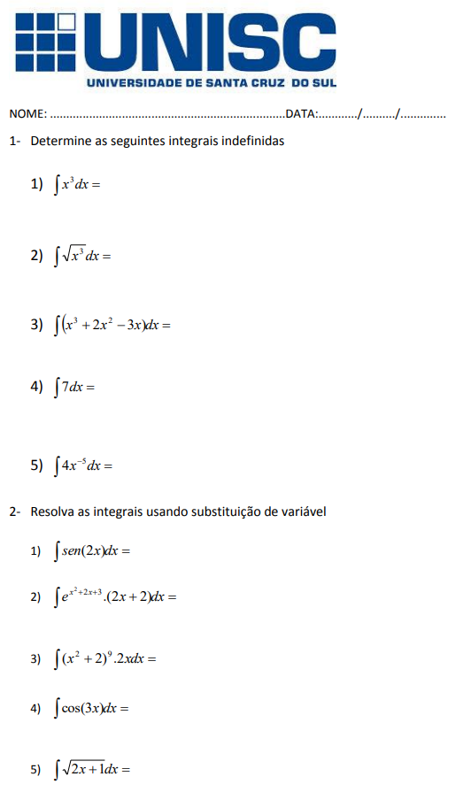

$$\frac{x^{4}}{4}+2*\frac{x^{3}}{3}-3*\frac{x^{2}}{2}$$

$$7x+c$$

$$4.\int{x^{-5}dx = }-\frac{1}{x^{4}}+c$$

$$\sqrt{3}x\sqrt{x}-\frac{\sqrt{x^{3}}}{\sqrt{3}}+c$$

$$\frac{x^{4}}{4}+c$$

Victor Kist

∫sen(u)1/2du 🡪 ½(-cos(u)) 🡪 -1/2cos(2x)+c



∫ex2+2x+3(2x+2) 🡪 2∫ ex2+2x+3(x-1)dx 🡪 x2+2x+3=u 🡪 ∫eudu=eu 🡪 2∫eu/2du 🡪 2.1/2.eudu 🡪 1.eudu 🡪 ex2+2x+3+c



